**WEEK 8**

**(A)AIM:** To develop an applet in Java that displays a simple message.

**THEORY:** Applets are designed to bring the web alive. They function to add animation sound and eventually complete multi-media into HTML documents. Java is also part of the future of interfacing with virtual reality environments. At present, java is limited only by the capabilities of the internet itself. Applets are java programs that are specialized for use over the Web.

**ALGORITHM:**

STEP1: START

STEP2: Create an applet using extends Applet class.

STEP3: Using drawString() method in the paint() method, display the simple message in required coordinates.

STEP4: Include the applet tag in the HTML code

STEP5: Execute an applet using the web-browser.

STEP6: END

**SOURCE CODE:**

import java.applet.*;

import java.awt.*;

/*<applet code="SimpleApplet" height=300 width=300>

</applet>*/

public class SimpleApplet extends Applet{

public void paint(Graphics g)

{

g.setColor(Color.pink);

setBackground(Color.yellow);

g.drawString("HI APPLET Program",80,150);

}

}

**OUTPUT:**

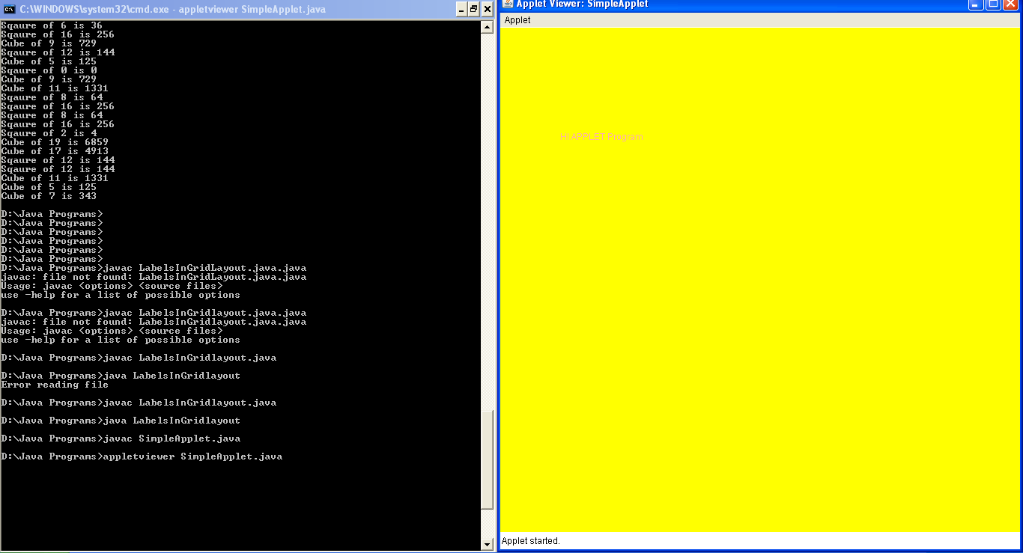

**(B)AIM:** To applet to compute factorial value

**THEORY:** The Applet life cycle: The init()Method: The init()method is where your applet does much of its setup such as defined its layout, parsing parameters or setting the background colors. The start() Method: The start()method is used mainly when implementing threads in java. The stop() Method: The stop() method is used to do what its name suggests: stop what is going on. The destroy() method: when it is called, the applet is told to free up system resources.

**ALGORITHM:**

STEP1: START

STEP2: Create an applet using extends Applet class.

STEP3: Create two textfields , one for to enter the number and another for result purpose.

STEP4: Create two buttons, one for compute and another button to clear the textfields data.

STEP5: Get the values from the textfield using getText() method.

STEP6: Compute the factorial value and set the result in the Result textfield.

STEP7: Include the applet tag in html and run the applet in the browser.

STEP8: END

**SOURCE CODE:**

import java.applet.*;

import java.awt.*;

import java.awt.event.*;

/*<applet code=Fact width=500 height=500></applet>*/

public class Fact extends Applet implements ActionListener

{

Button b1,b2;

Label l1,l2;

TextField tf1,tf2;

public void init()

{

b1=new Button("COMPUTE");

b1.addActionListener(this);

b2=new Button("CLEAR");

b2.addActionListener(this);

tf1=new TextField(20);

tf2=new TextField(20);

l1=new Label("NUMBER");

l2=new Label("RESULT");

add(l1);

add(tf1);

add(l2);

add(tf2);

add(b1);

add(b2);

}

public void actionPerformed(ActionEvent e)

{

if(e.getSource()==b1)

{

int a=Integer.parseInt(tf1.getText());

int fact=1;

for(int i=1;i<=a;i++)

fact*=i;

tf2.setText(""+fact);

}

else

{

tf1.setText("");

tf2.setText("");

} } }

**OUTPUT:**

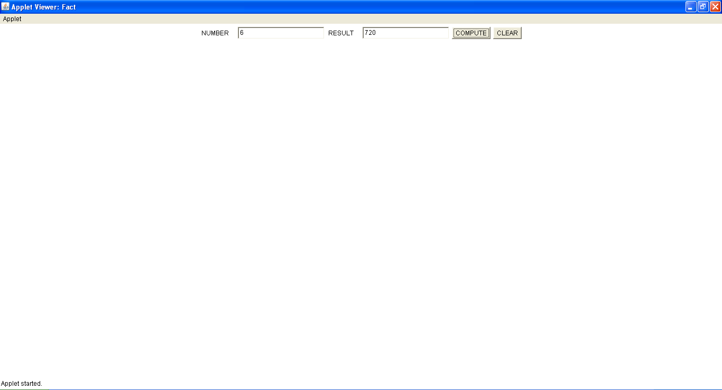

**VIVA - VOCE:**

1. What is the purpose of setText() and getText() methods?

setText() method is used to set text into the TextField specified through object. It’s return type is void. getText() method is used to get text from the TextField specified through object. It’s return type is String.

2. What is the purpose of getSource() method?

getSource() method returns the command string associated with this action. getSource() returns the object on which the Event initially occurred.

1. What is the use of actionListener()?

The Java ActionListener is notified whenever you click on the button or menu item. It is notified against ActionEvent. The ActionListener interface is found in java.awt.event package. It has only one method: actionPerformed().

4. What is an applet?

Applet is a Java program that can be embedded into a web page. It runs inside the web browser and works at client side. Applet is embedded in a HTML page using the APPLET or OBJECT tag and hosted on a web server.

5. What are the Life cycle methods of Applet?

When an applet begins, the following methods are called, in this sequence:

1. init( )  
2. start( )  
3. paint( )

When an applet is terminated, the following sequence of method calls takes place:  
1. stop( )  
2. destroy( )